**Spotify Assignment**

1. **Check the entire dataset**

CREATE OR REPLACE TABLE RS_SPOTIFY_DATA

(

playlist_url VARCHAR(100),

year INT,

track_id VARCHAR(100),

track_name VARCHAR(100),

track_popularity INT,

album VARCHAR(100),

artist_id VARCHAR(100),

artist_name VARCHAR(100),

artist_genres VARCHAR(180),

artist_popularity INT,

danceability NUMBER(12),

energy NUMBER(8),

key NUMBER(5),

loudness NUMBER(12),

mode NUMBER(2),

speechiness NUMBER(12),

acousticness NUMBER(9),

instrumentalness NUMBER(12),

liveness NUMBER(5,4),

valence NUMBER(5,4),

tempo NUMBER(6,3),

duration_ms INT,

time_signature INT

);

SELECT * FROM RS_SPOTIFY_DATA LIMIT 50;

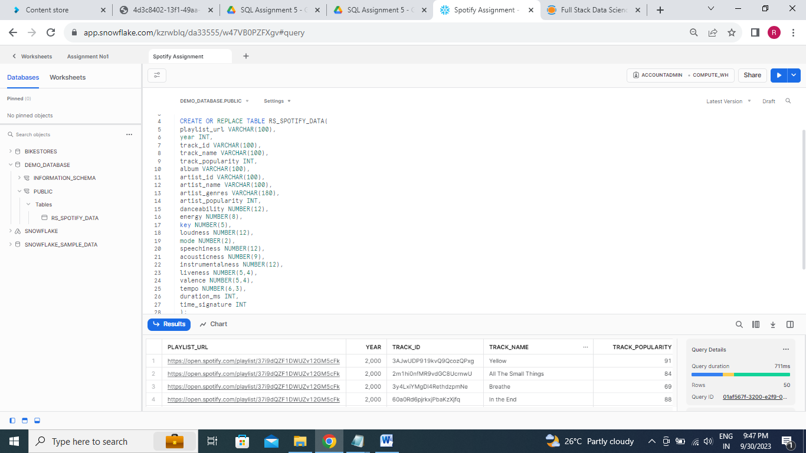

**2.Number of songs on Spotify for each artist**

SELECT ARTIST_NAME, COUNT(TRACK_NAME) AS COUNT_OF_SONGS

FROM RS_SPOTIFY_DATA

GROUP BY 1

ORDER BY 2 DESC;

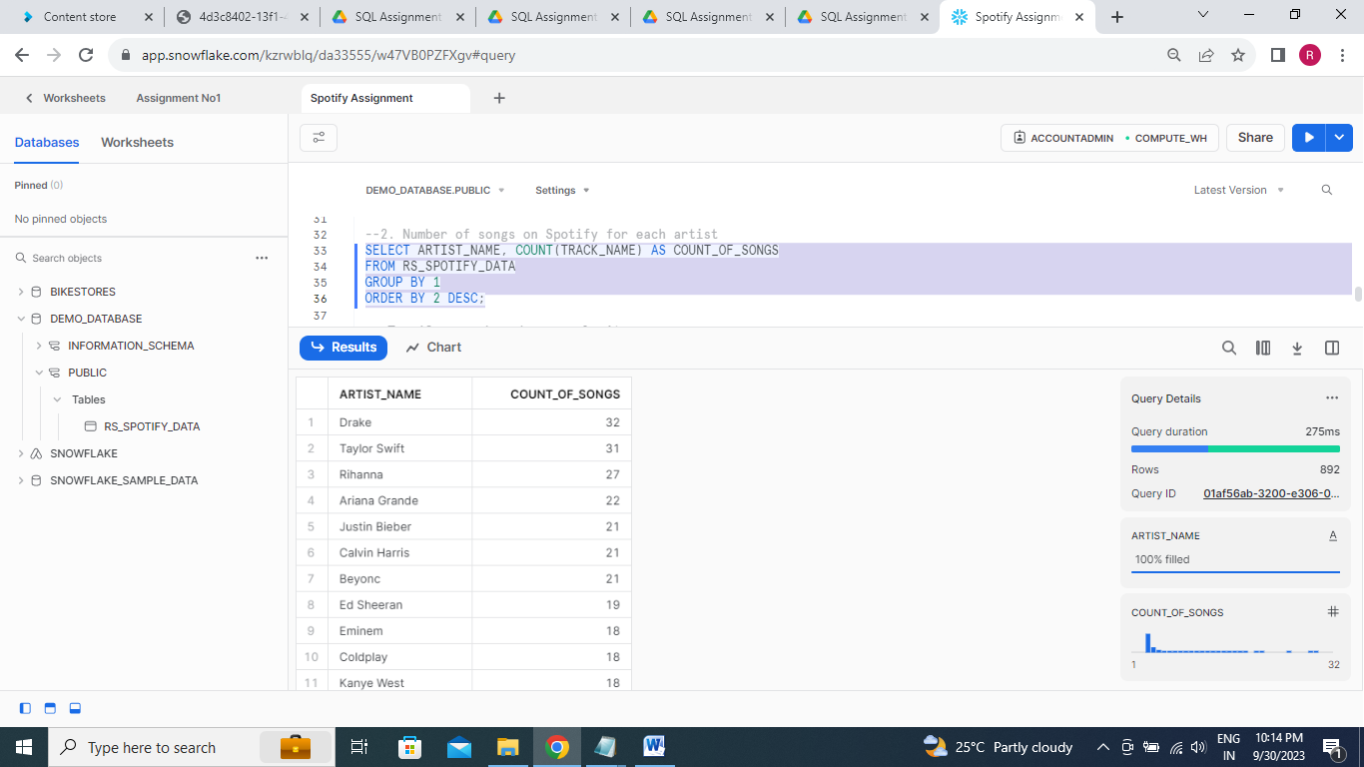

**3.Top 10 songs based on popularity**

SELECT TRACK_NAME,TRACK_POPULARITY

FROM RS_SPOTIFY_DATA

ORDER BY 2 DESC

LIMIT 10;

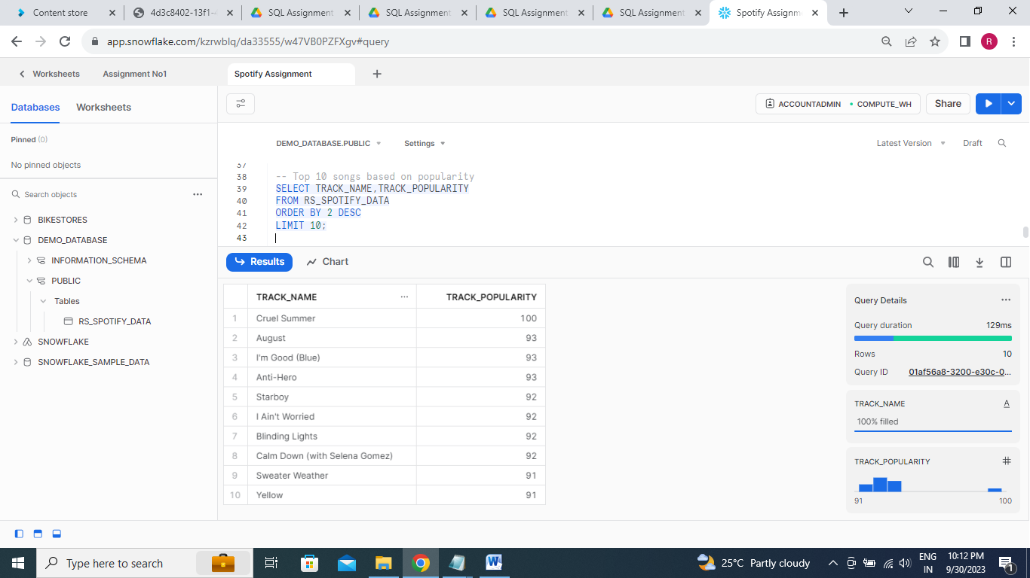**4. Total number of songs on spotify based on year**

SELECT YEAR, COUNT(TRACK_NAME) AS TOTAL_SONG_ON_SPOTIFY

FROM RS_SPOTIFY_DATA

GROUP BY 1

ORDER BY 1 DESC;

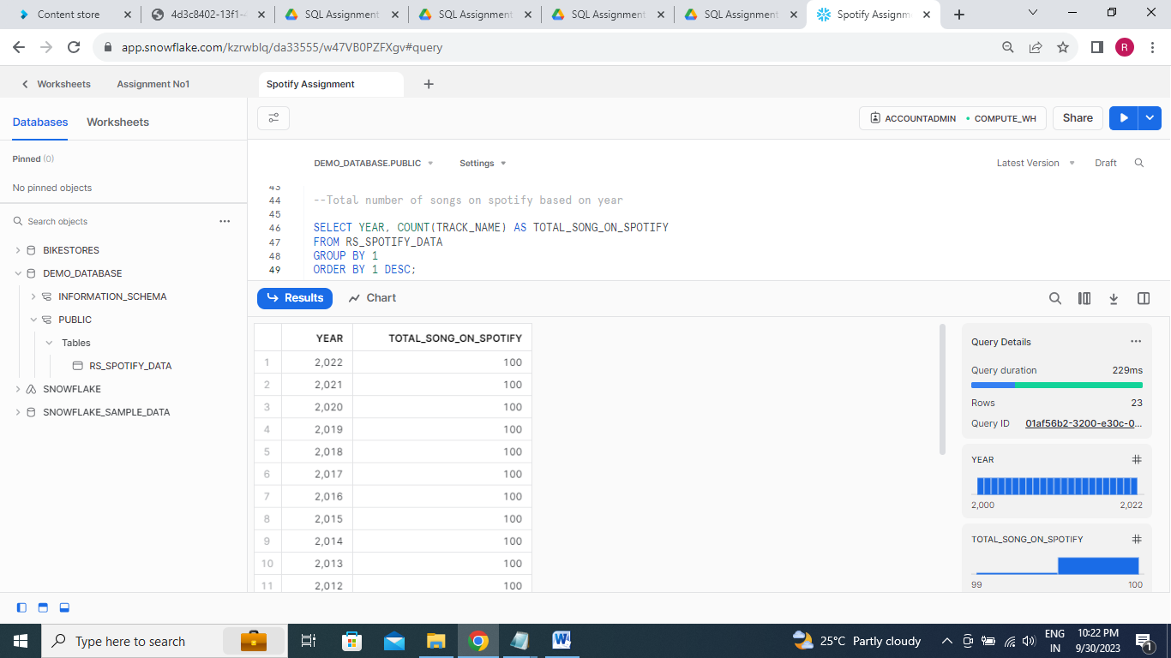

**5.Top song for each year (2000-2022) based on popularity**

SELECT MAX(TRACK_NAME) AS TOP_SONG, YEAR, MAX(TRACK_POPULARITY) AS

MAX_TRACK_POPULARITY

FROM RS_SPOTIFY_DATA

WHERE YEAR BETWEEN 2000 AND 2022

GROUP BY YEAR

ORDER BY YEAR, MAX_TRACK_POPULARITY DESC;

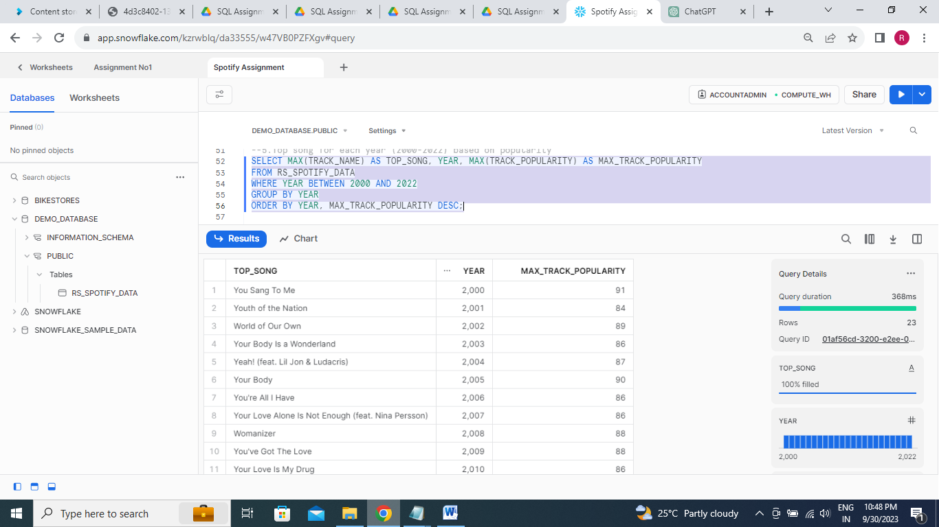

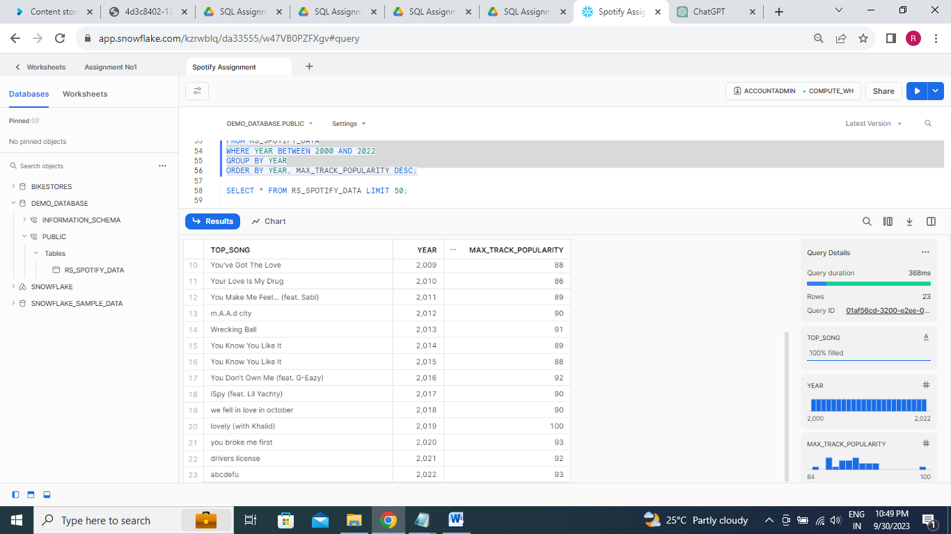

**6. Analysis based on Tempo :**

**tempo > 121.08 -> 'Above Average Tempo'**

**tempo = 121.08 -> 'Average Tempo'**

**tempo < 121.08 -> 'Below Average Tempo'**

SELECT TRACK_NAME, TEMPO,

CASE

WHEN TEMPO > 121.08 THEN 'Above Average Tempo'

WHEN TEMPO = 121.08 THEN 'Average Tempo'

WHEN TEMPO < 121.08 THEN 'Below Average Tempo'

END TEMPO

FROM RS_SPOTIFY_DATA;

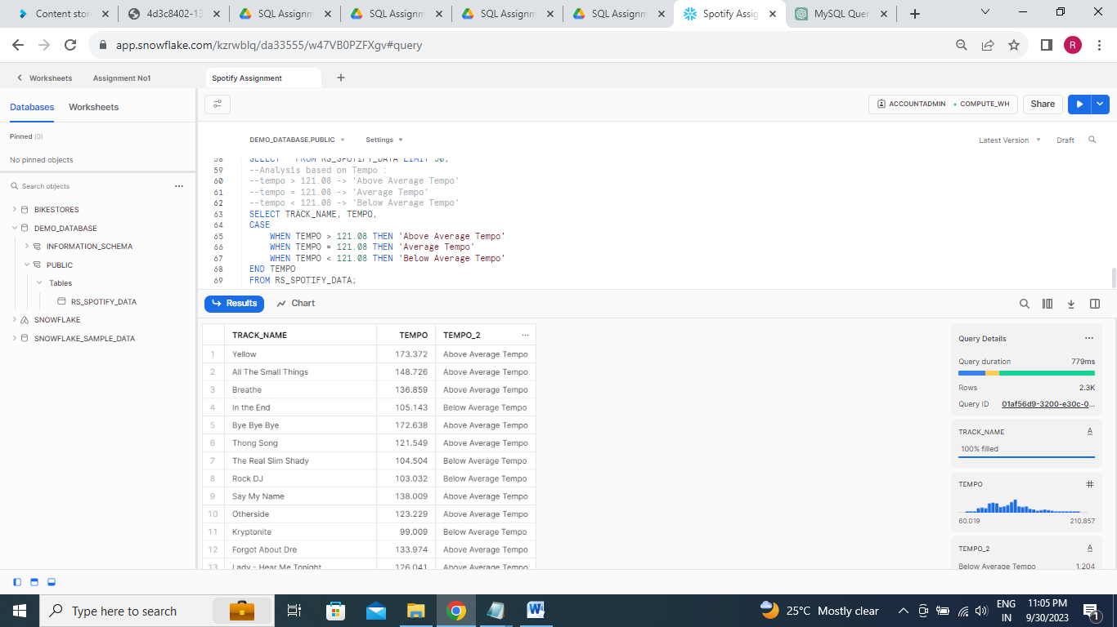

**7. Songs with Highest Tempo**

SELECT TRACK_NAME AS SONGS,MAX(TEMPO) AS HIGHEST_TEMPO FROM RS_SPOTIFY_DATA

GROUP BY 1

ORDER BY 2 DESC LIMIT 1;

**-- OR--**

SELECT TRACK_NAME AS SONGS, TEMPO AS HIGHEST_TEMPO FROM RS_SPOTIFY_DATA

WHERE HIGHEST_TEMPO =

(SELECT MAX(TEMPO) FROM RS_SPOTIFY_DATA);

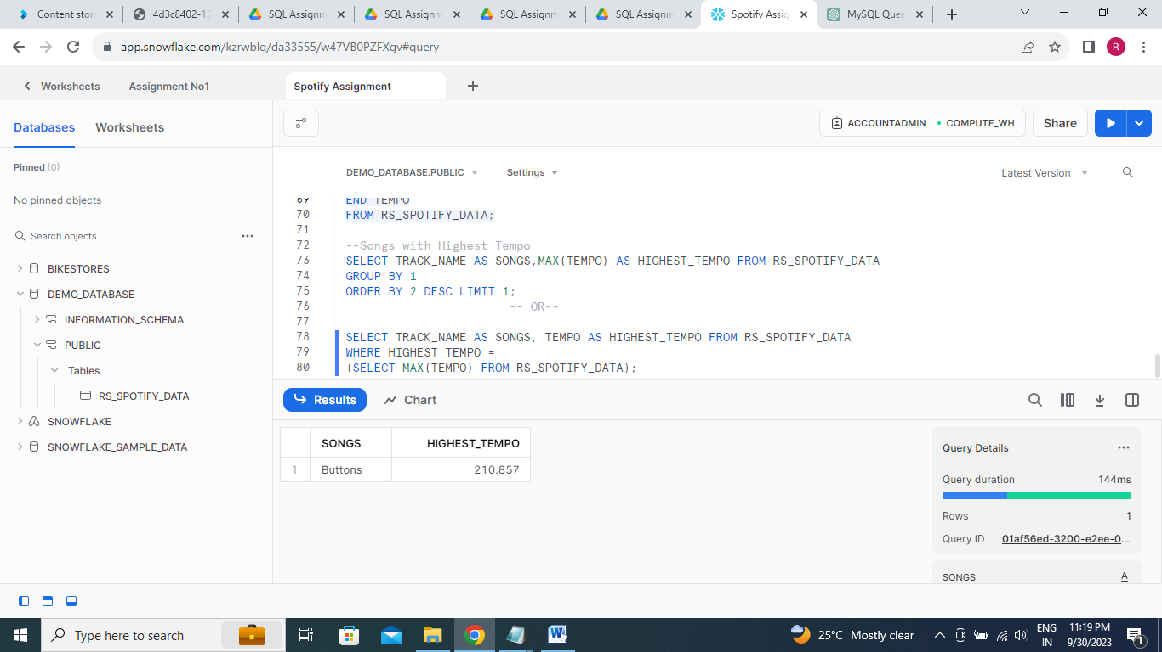

**8. Number of Songs for different Tempo Range : track_name, energy**

**Modern_Music -> tempo BETWEEN 60.00 AND 100.00**

**Classical_Music -> tempo BETWEEN 100.001 AND 120.00**

**Dance_Music -> tempo BETWEEN 120.001 AND 150.01**

**HighTempo_Music -> tempo > 150.01**

SELECT TRACK_NAME,ENERGY, TEMPO,

CASE

WHEN TEMPO BETWEEN 60.00 AND 100.00 THEN 'Modern_Music'

WHEN TEMPO BETWEEN 100.001 AND 120.00 THEN 'Classical_Music'

WHEN TEMPO BETWEEN 120.001 AND 150.01 THEN 'Dance_Music'

WHEN TEMPO > 150.01 THEN 'HighTempo_Music'

END TEMPO_RANGE

FROM RS_SPOTIFY_DATA;

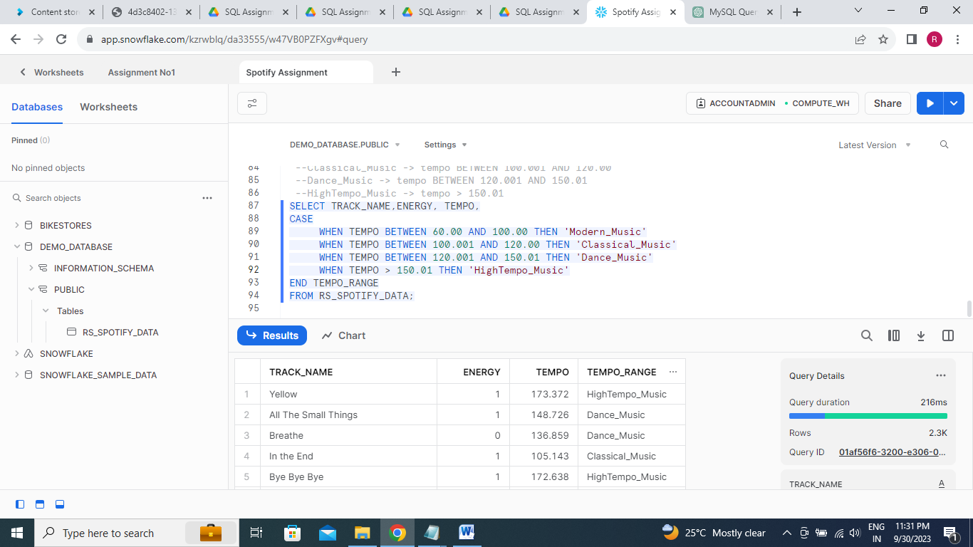

**9.** **Energy Analysis : TOP 10 track_name, danceability, track_popularity**

**energy > 0.64 -> 'Above Average Energy**

**energy = 0.64 -> 'Average Energy’**

**energy < 0.64 -> 'Below Average Energy’**

**energy BETWEEN 0.1 AND 0.3 -> 'Calm Music'**

**energy BETWEEN 0.3 AND 0.6 -> 'Moderate Music'**

**Energy >0.6 -> ‘Energetic Music'**

SELECT TOP 10 TRACK_NAME, DANCEABILITY, TRACK_POPULARITY,

CASE

WHEN ENERGY > 0.64 THEN 'Above Average Energy'

WHEN ENERGY = 0.64 THEN 'Average Energy'

WHEN ENERGY < 0.64 THEN 'Below Average Energy'

WHEN ENERGY BETWEEN 0.1 AND 0.3 THEN 'Calm Music'

WHEN ENERGY BETWEEN 0.3 AND 0.6 THEN 'Moderate Music'

WHEN ENERGY >0.6 THEN 'Energetic Music'

END ENERGY_ANALYSIS

FROM RS_SPOTIFY_DATA;

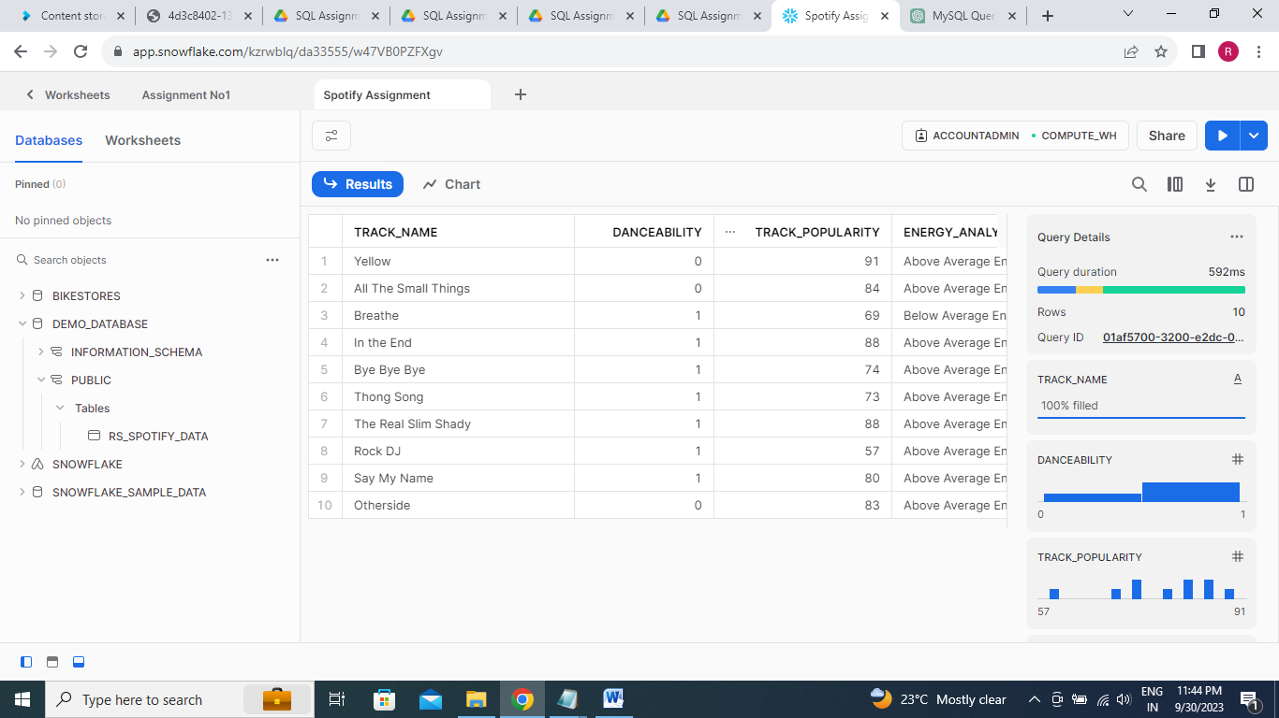

**10. Number of Songs for different energy ranges(above)**

SELECT COUNT(TRACK_NAME),

CASE

WHEN ENERGY > 0.64 THEN 'Above Average Energy'

WHEN ENERGY = 0.64 THEN 'Average Energy'

WHEN ENERGY < 0.64 THEN 'Below Average Energy'

WHEN ENERGY BETWEEN 0.1 AND 0.3 THEN 'Calm Music'

WHEN ENERGY BETWEEN 0.3 AND 0.6 THEN 'Moderate Music'

WHEN ENERGY >0.6 THEN 'Energetic Music'

END ENERGY_ANALYSIS

FROM RS_SPOTIFY_DATA

GROUP BY 2

ORDER BY 1 DESC;

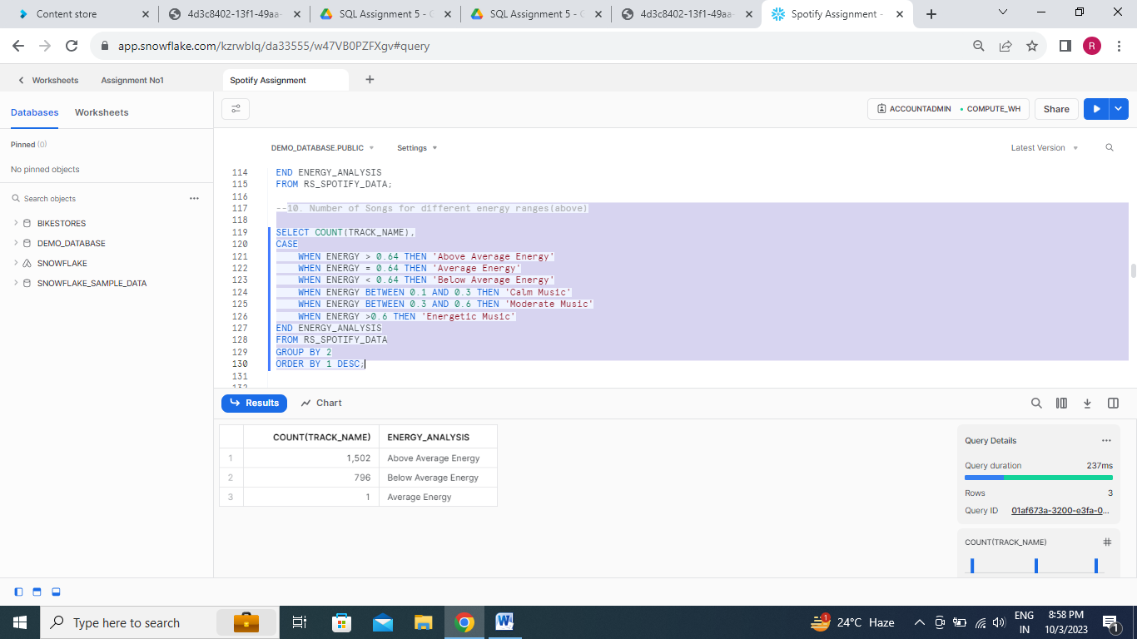

**11. Danceability Analysis : Top 20 track_name, danceability**

**danceability BETWEEN 0.69 AND 0.79 -> 'Low Danceability'**

**(danceability BETWEEN 0.49 AND 0.68) OR (danceability BETWEEN ACCOUNT0.79 AND 0.89) -> 'Moderate Danceability'**

**ACCOUNT(danceability BETWEEN 0.39 AND 0.49) OR (danceability BETWEEN 0.89 AND 0.99) -> 'High Danceability'**

**danceability < 0.39 OR danceability > 0.99 -> 'Cant Dance on this one'**

SELECT TOP 20 TRACK_NAME AS TOP_20_SONGS,DANCEABILITY,

CASE

WHEN DANCEABILITY BETWEEN 0.69 AND 0.79 THEN 'Low Danceability'

WHEN (DANCEABILITY BETWEEN 0.49 AND 0.68) OR (DANCEABILITY BETWEEN 0.79 AND

0.89) THEN 'Moderate Danceability'

WHEN (DANCEABILITY BETWEEN 0.39 AND 0.49) OR (DANCEABILITY BETWEEN 0.89 AND

0.99) THEN 'High Danceability'

WHEN DANCEABILITY < 0.39 OR DANCEABILITY > 0.99 THEN 'Cant Dance on this one'

END AS DANCEABILITY_RANGES_BUCKET

FROM RS_SPOTIFY_DATA

Order by 2 desc;

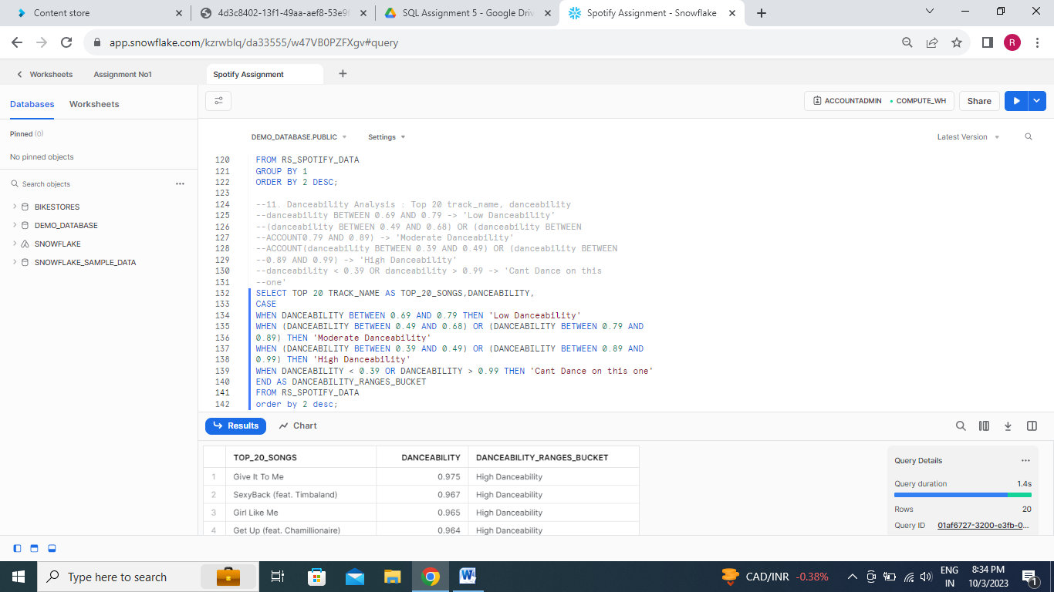

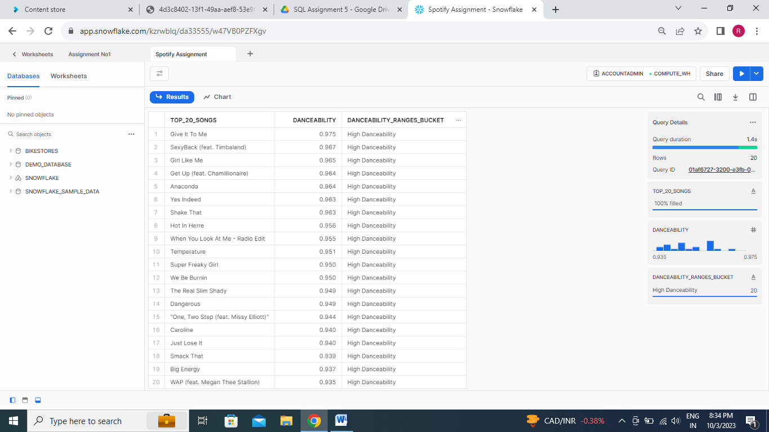

**12. Number of Songs for different danceability ranges(above)**

SELECT COUNT(*) AS SONGS_FOR_DIFF_DANCEABILITY,

CASE

WHEN DANCEABILITY BETWEEN 0.69 AND 0.79 THEN 'Low Danceability'

WHEN (DANCEABILITY BETWEEN 0.49 AND 0.68) OR (DANCEABILITY BETWEEN 0.79 AND

0.89) THEN 'Moderate Danceability'

WHEN (DANCEABILITY BETWEEN 0.39 AND 0.49) OR (DANCEABILITY BETWEEN 0.89 AND

0.99) THEN 'High Danceability'

WHEN DANCEABILITY < 0.39 OR DANCEABILITY > 0.99 THEN 'Cant Dance on this one'

ELSE 'OTHERS'

END AS DANCEABILITY_RANGES_BUCKET

FROM RS_SPOTIFY_DATA

GROUP BY 2

ORDER BY 1 DESC;

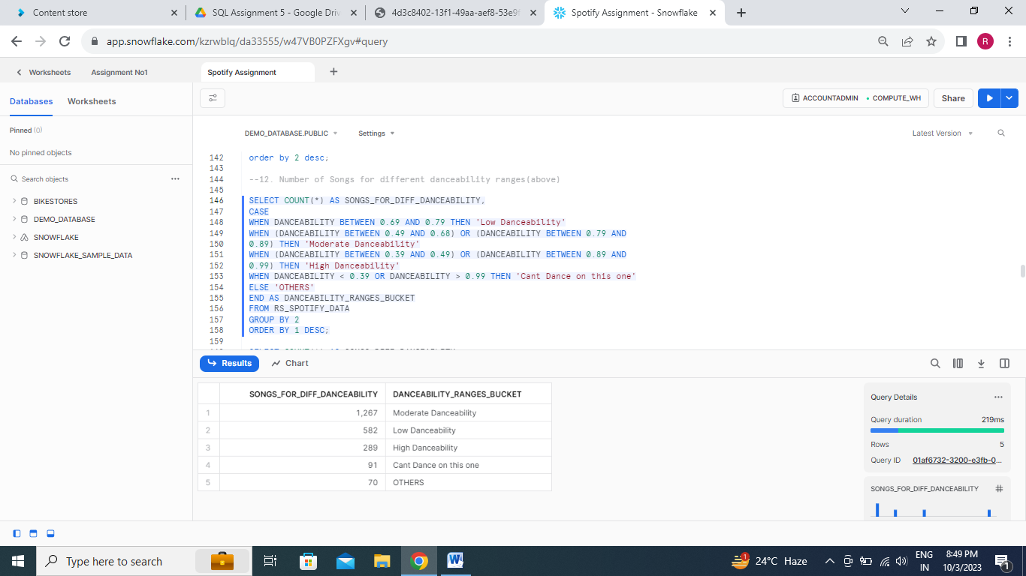

**13.Loudness Analysis : Top 20 track_name, loudness,**

**loudness BETWEEN -23.00 AND -15.00 ->'Low Loudness'**

**loudness BETWEEN -14.99 AND -6.00 -> 'Below Average Loudness'**

**loudness BETWEEN -5.99 AND -2.90 -> 'Above Average Loudness'**

**loudness BETWEEN -2.89 AND -1.00 -> 'Peak Loudness'**

SELECT TOP 20 TRACK_NAME, LOUDNESS,

CASE

WHEN LOUDNESS BETWEEN -23.00 AND -15.00 THEN 'LOW LOUDNESS'

WHEN LOUDNESS BETWEEN -14.99 AND -6.00 THEN 'BELOW AVERAGE LOUDNESS'

WHEN LOUDNESS BETWEEN -5.99 AND -2.90 THEN 'ABOVE AVERAGE LOUDNESS'

WHEN LOUDNESS BETWEEN -2.89 AND -1.00 THEN 'PEAK LOUDNESS'

END LOUDNESS_ANALYSIS

FROM RS_SPOTIFY_DATA;

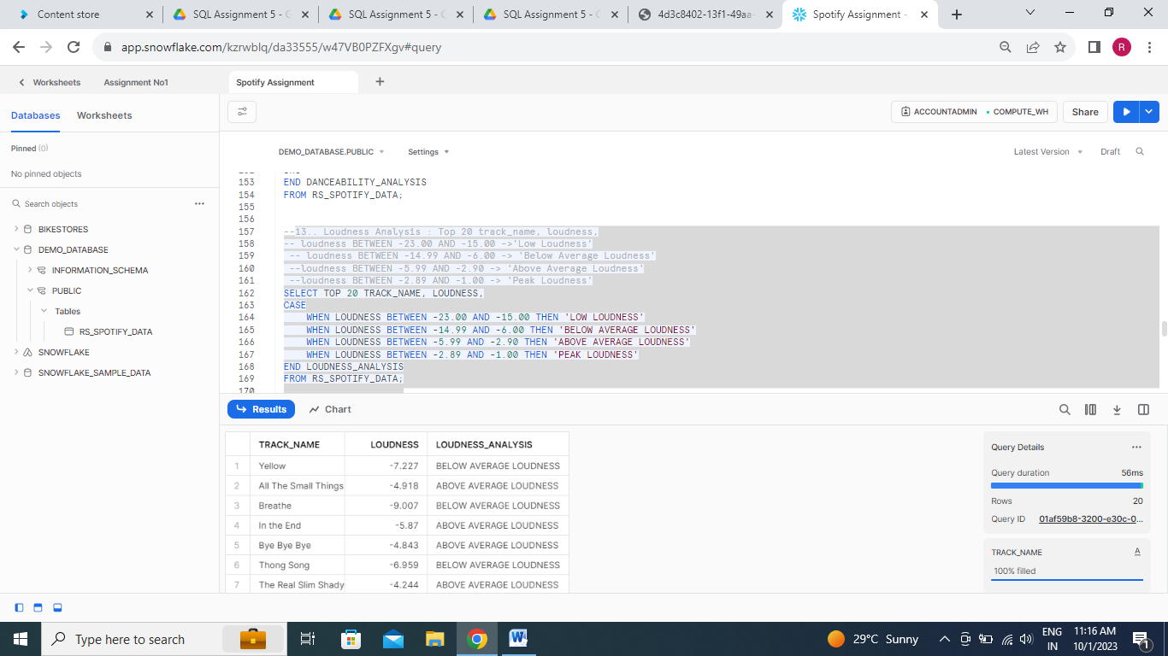

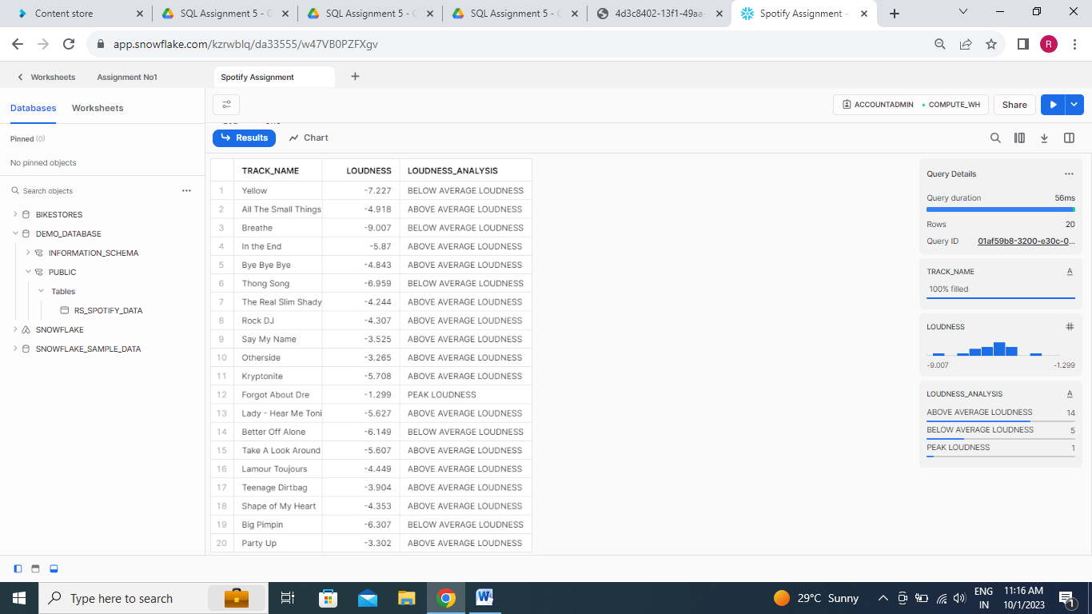

**14. Number of Songs for different loudness ranges(above)**

SELECT COUNT(*) AS SONGS_FOR_DIFF_LOUDNESS,

CASE

WHEN LOUDNESS BETWEEN -23.00 AND -15.00 THEN 'LOW LOUDNESS'

WHEN LOUDNESS BETWEEN -14.99 AND -6.00 THEN 'BELOW AVERAGE LOUDNESS'

WHEN LOUDNESS BETWEEN -5.99 AND -2.90 THEN 'ABOVE AVERAGE LOUDNESS'

WHEN LOUDNESS BETWEEN -2.89 AND -1.00 THEN 'PEAK LOUDNESS'

ELSE 'OTHERS'

END LOUDNESS_ANALYSIS

FROM RS_SPOTIFY_DATA

GROUP BY 2

ORDER BY 1 DESC;

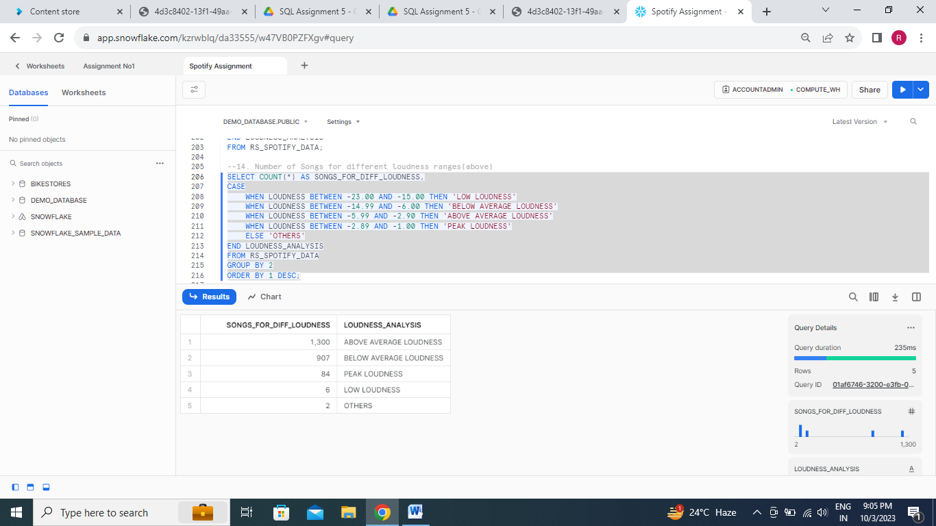

**15. Valence Analysis : Top 20 track_name, valence, track_popularity,**

**valence > 0.535 -> Above Avg Valence**

**valence = 0.535 -> Avg Valence**

**valence < 0.535 -> Below Average'**

SELECT TOP 20 TRACK_NAME,TRACK_POPULARITY, VALENCE,

CASE

WHEN VALENCE > 0.535 THEN 'ABOVE AVG VALENCE'

WHEN VALENCE = 0.535 THEN 'AVG VALENCE'

WHEN VALENCE < 0.535 THEN 'BELOW VALENCE'

END VALENCE_ANALYSIS

FROM RS_SPOTIFY_DATA

ORDER BY 2 DESC;

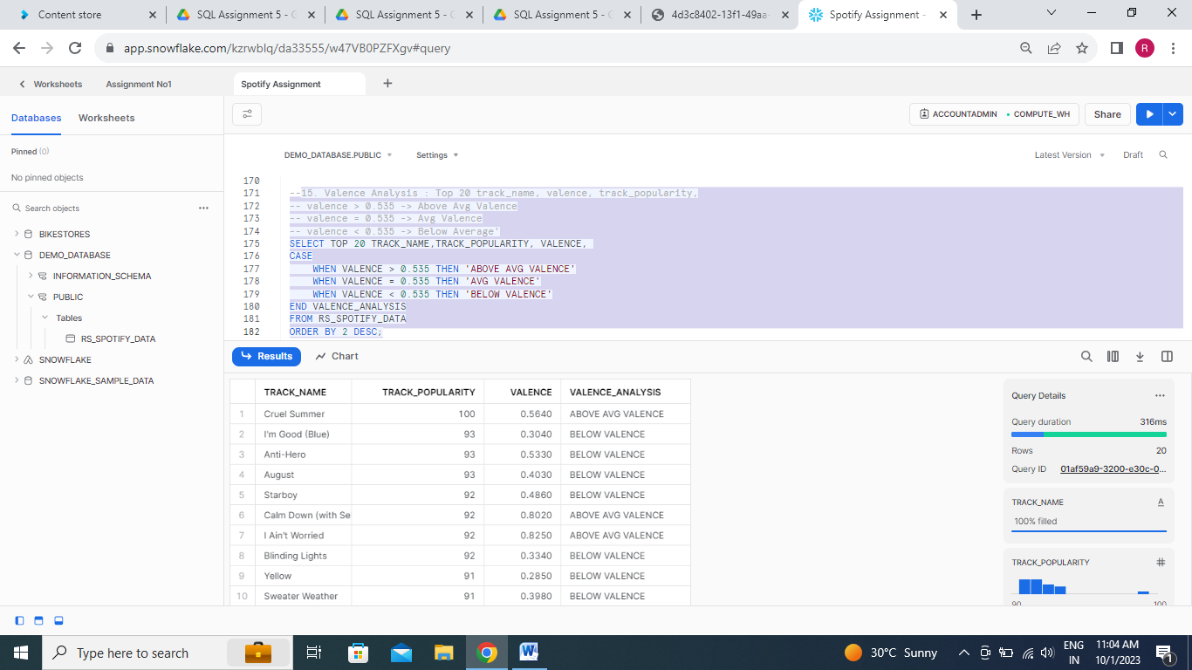

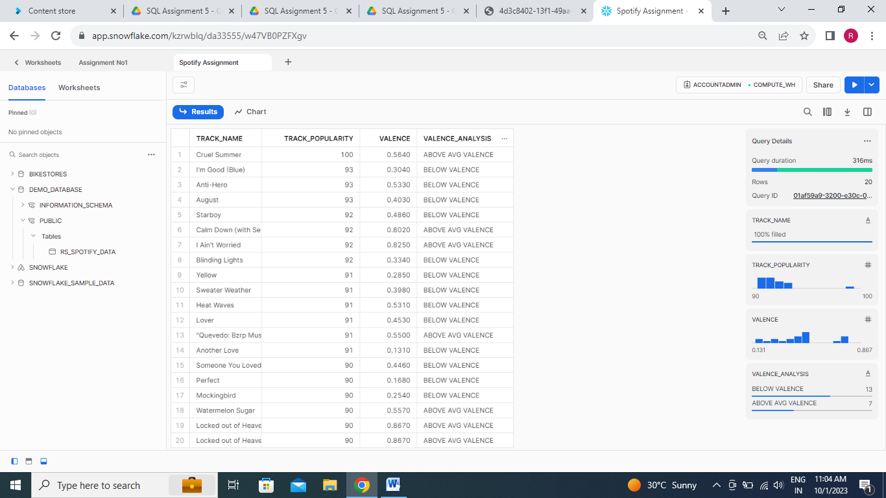

**16. Number of Songs for different valence ranges(above)**

SELECT COUNT(*) AS SONGS_FOR_DIFF_VALENCE,

CASE

WHEN VALENCE > 0.535 THEN 'ABOVE AVG VALENCE'

WHEN VALENCE = 0.535 THEN 'AVG VALENCE'

WHEN VALENCE < 0.535 THEN 'BELOW VALENCE'

END VALENCE_ANALYSIS

FROM RS_SPOTIFY_DATA

GROUP BY 2

ORDER BY 1 DESC;

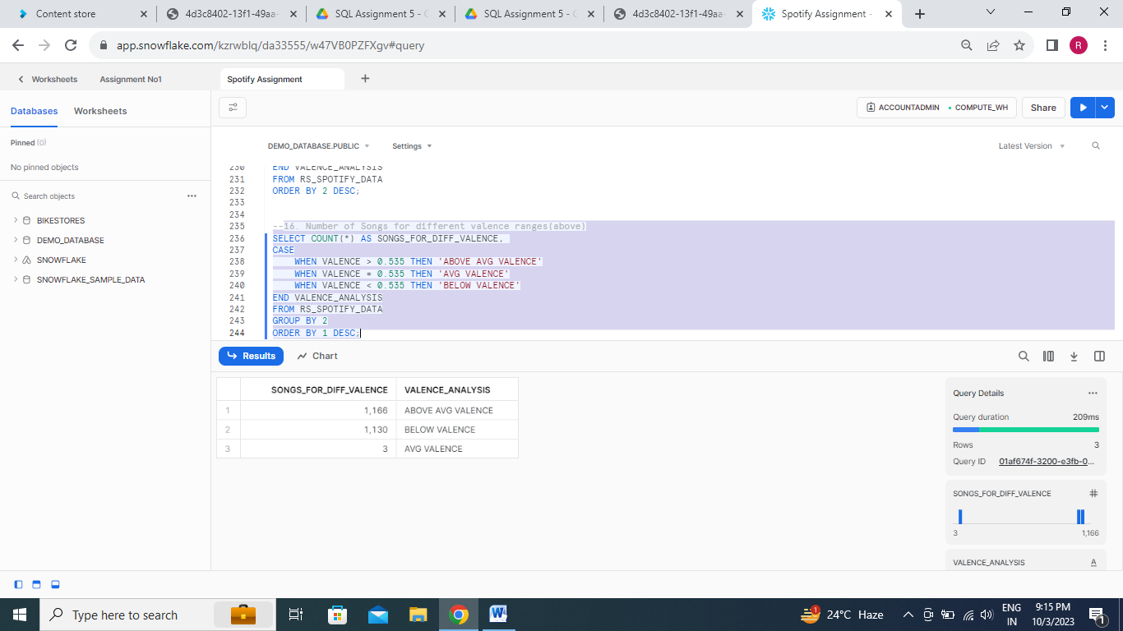

**17.** **Speechiness Analsis : Top 20 track_name, speechiness, tempo,**

**speechiness > 0.081-> Above Avg Speechiness**

**speechiness = 0.081-> Avg Speechiness**

**speechiness < 0.081-> Below Speechiness**

SELECT TOP 20 TRACK_NAME,TEMPO,SPEECHINESS,

CASE

WHEN SPEECHINESS > 0.081 THEN 'ABOVE AVG SPEECHINESS'

WHEN SPEECHINESS = 0.081 THEN 'AVG SPEECHINESS'

WHEN SPEECHINESS < 0.081 THEN 'BELOW SPEECHINESS'

END SPEECHINESS_ANALYSIS

FROM RS_SPOTIFY_DATA;

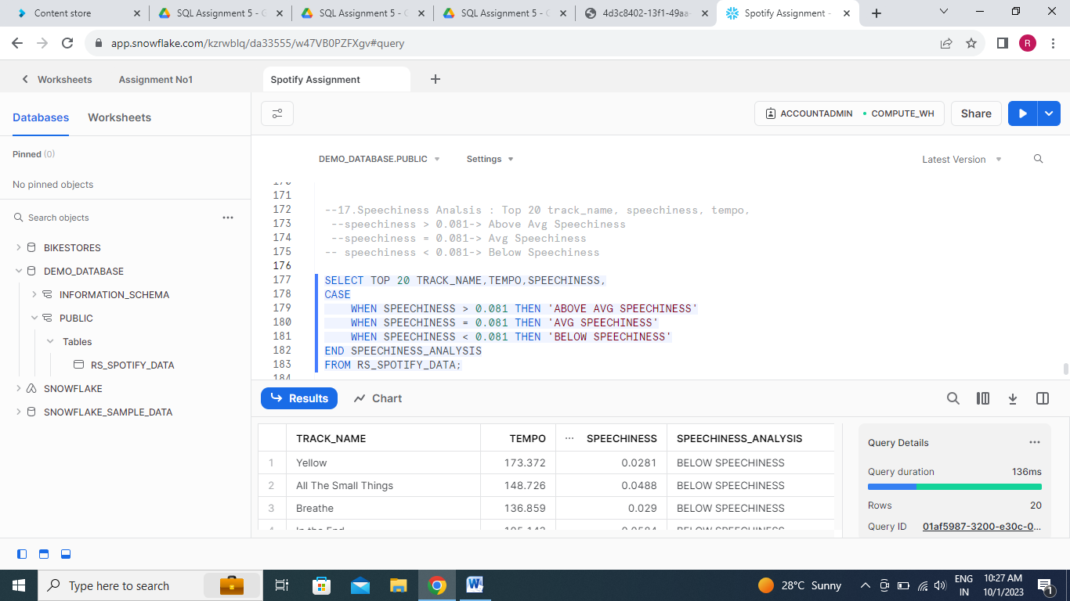

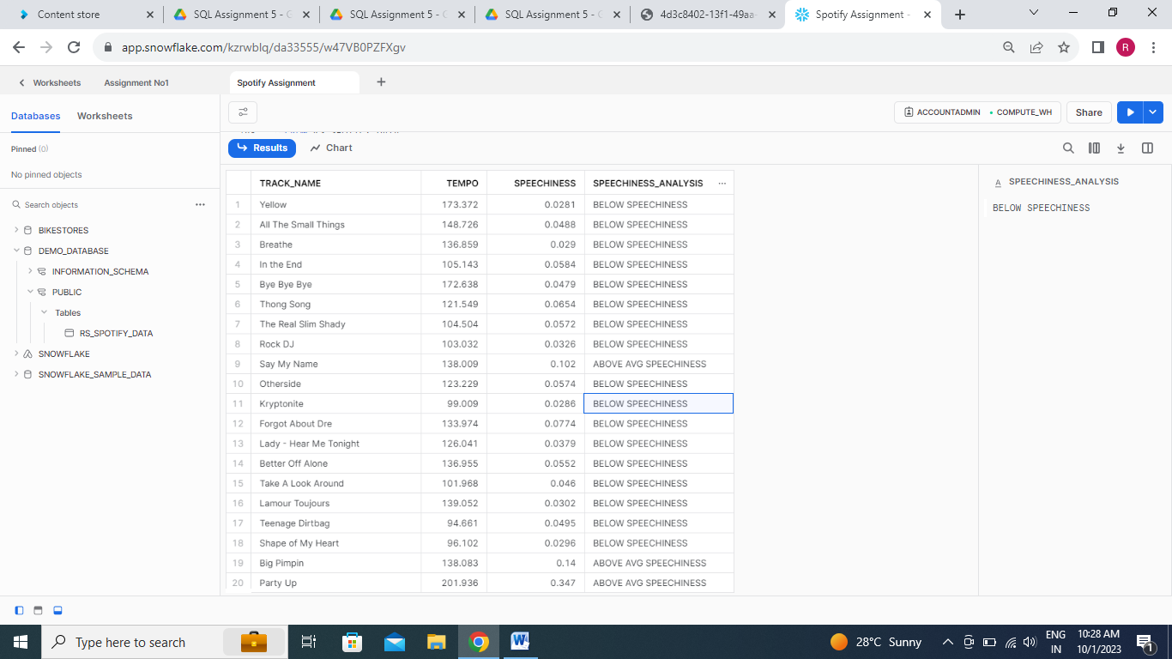

**18.Acoustic Analysis : DISTINCT TOP 25 track_name, album, artist_name, acousticness**

**(acousticness BETWEEN 0 AND 0.40000 -> 'Not Acoustic'**

**(acousticness BETWEEN 0.40001 AND 0.80000) ->'Acoustic'**

**(acousticness BETWEEN 0.80001 AND 1) ->'Highly Acoustic**

SELECT DISTINCT TOP 25 TRACK_NAME,ALBUM, ARTIST_NAME,ACOUSTICNESS,

CASE

WHEN ACOUSTICNESS BETWEEN 0 AND 0.40000 THEN 'NOT ACOUSTIC'

WHEN ACOUSTICNESS BETWEEN 0.40001 AND 0.80000 THEN 'ACOUSTIC'

WHEN ACOUSTICNESS BETWEEN 0.80001 AND 1 THEN 'HIGHLY ACOUSTIC'

END ACOUSTIC_ANALYSIS

FROM RS_SPOTIFY_DATA;

